caGrid iPhone App

Testing Guidelines

Revision Document History
Date | Version | Description | Author
10/7/2010 | 1.0 | First draft | Konrad Rokicki
10/18/2010 | 1.01 | Modified by David Li
Table of Contents
Introduction 4
Technical Background 4
Supporting Infrastructure 4
Grid Summary Service 5
Test Plan 6
Prerequisites 6
Testing the Dashboard 6
Testing Microarray Search 7
Testing other data types 8
Generating New Search Terms 8
Testing Search in Progress 9
Testing Search Result Summary 9
Testing Search Results 10
Testing Grid Service List 11
Testing Favorites 12
Testing Hosting Center List 13
Testing Service Subtitle Option 14
Testing History Option 15
Testing Show Hidden Services Option 16

Introduction
The caGrid iPhone App is a native iPhone application which can run on the iPod Touch, iPhone, and iPad devices. Testing of this application will be completed on iPod Touch devices.
The application has several primary capabilities:
- A caGrid dashboard with summary statistics about the grid
- Ability to perform keyword searches on certain data services
- Ability to view results returned from the keyword searches
- List of services on the grid and details for each
- List of hosting institutions and details for each
- Ability to add a service or host to a “favorites” list
This document aims to provide initial guidelines for testing all of the primary functionality of the iPhone application. Testing should be in no way limited to the steps laid out in this document.

Technical Background

Supporting Infrastructure
The application communicates with a single service on the backend – the Grid Summary Service (GSS). GSS instances are available on each of the standard CBIIT deployment tiers: Dev, QA, Stage and Production (see Figure 1). Each GSS instance communicates with an instance of caB2B for running keyword searches.
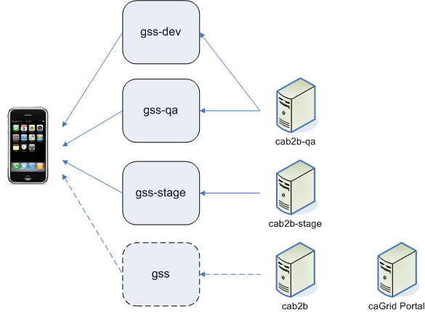
Figure 1: Supporting Infrastructure for the iPhone App

It is important to note that all tiers of GSS and caB2B communicate with the production caGrid. The caGrid Portal on the production tier may be used to verify certain data and search results.

Grid Summary Service
The GSS caches information about the grid in a MySQL database, and provides it to the iPhone in a timely manner. Every six (6) hours the GSS scans the caGrid Index Service for changes in service metadata and updates its local MySQL cache. At this time the GSS also executes a count query for every object on every data service on the grid, and caches those count results as well.
GSS also proxies keyword searches for the iPhone by offloading them to the configured caB2B instance. Results coming back from caB2B are cached temporarily in an EhCache by GSS until the iPhone is able to pick them up.
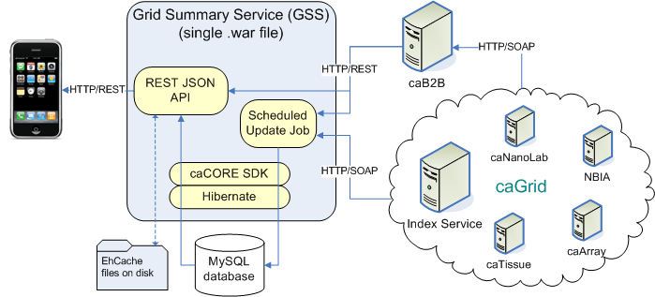
Updated Every 6 hours
Figure 2: Detailed Architecture

Test Guidelines

Prerequisites
The latest version of the iPhone application should be installed on the device and configured to point to the instance of GSS which is being tested.

Testing the Dashboard
The dashboard pulls aggregate data from GSS which is not directly traceable to other systems. As a result, valid ranges for the counts is approximate.
Testing Steps
- Ensure that there are at least 100 services hosted by at least 50 institutions
- Ensure the screen displays all three data types:
  - Microarray
    - Ensure “X caArray services”
    - Ensure “X experiments”
  - Imaging
    - Ensure “X NBIA services”
    - Ensure X image services”
  - Nanoparticle
    - Ensure “X caNanolab services”
    - Ensure “X nanoparticles”
- Ensure that tapping the information icon in the upper right brings up the help screen
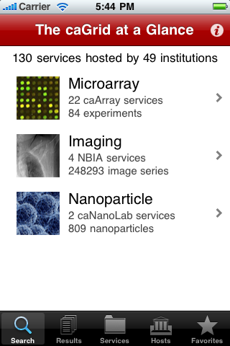

Testing Microarray Search
Testing Steps
- Tap the “Microarray” data type on the dashboard
- Ensure “Microarray” appears under “Type of data to search for”
- Tap the “Edit” button
- Select some services and then tap “Select None”
- Ensure no services are selected
- Select “caArray at CBIIT”
- Tap “Done” or the “Microarray Search” button in the upper left
- Tap the input box
- Type in “GBM” or another search term (see Generating New Search Terms)
- Tap “Search” on the keyboard OR tap the screen to minimize the keyboard and then tap the “Search” button
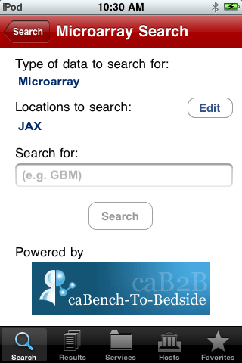 | 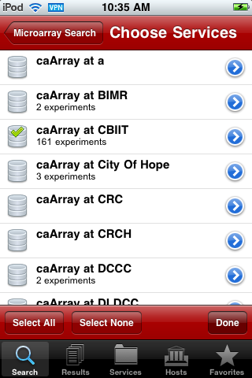

Testing Other Data Types
Follow the testing steps for Microarray Search with the following caveats:
- Use the search term suggested in the search input box for each data type OR generate a new search term (see Generating New Search Terms)

Generating New Search Terms
Search terms should be chosen so that their correct output is known and can be verified. The best way to generate search terms is by using caB2B. Refer to Figure 1 to determine which caB2B instance to use for the GSS tier being tested. The output of that caB2B instance should generally match the output of the iPhone app’s keyword query. Begin by searching for a known search term and then look at the results for possible terms to search on.

Testing Search in Progress
After tapping the “Search” button, verify the following while the search is executing.
Testing Steps
- The screen changes to the “Your Searches” screen
- Your search term, location, and data type are displayed in the highlighted row
- The correct date/time is displayed
- The progress wheel animation is spinning
- You can exit the application or turn off the iPhone and come back later to retrieve results
- The progress wheel stops spinning in a reasonable amount of time (max 1 hour) and changes into a drilldown arrow
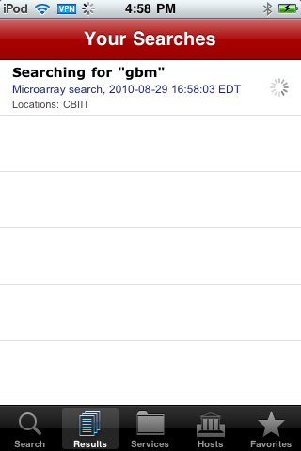

Testing Search Result Summary
Once the search is complete, the search will be selectable.
Testing Steps
- Ensure that the number of results is displayed
- Ensure you can drill down into the results screen
- Ensure the Search Parameters are correct
- Ensure that services are listed in their expected sections
- Tap the blue arrow next to a service and ensure that the correct service details are displayed
- Tap the service row to drill down into results for that service
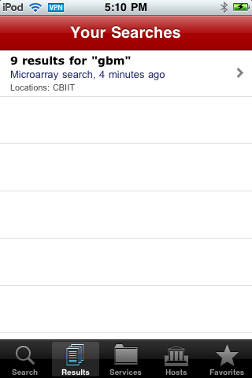 | 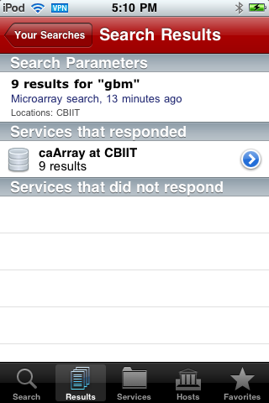

Testing Search Results
The search results should be comparable to a caB2B search with the same parameters. However, cab2B segregates by query and combines results across services. By contrast, the iPhone App combines results across all queries and segregates by service.
Testing Steps
- Ensure that each result has a title and description
- Tap a result to ensure the title and description can be found on the drill down screen
- Tap a result attribute which is truncated (i.e. ends with an ellipsis) to ensure that the entire attribute can be read
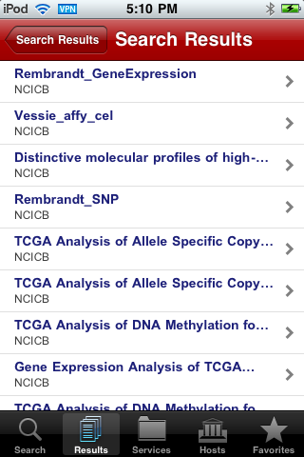 | 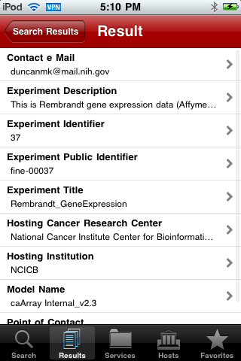

Testing Grid Service List
Testing Steps
- Tap the “Services” icon at the bottom of the screen
- Filter the services by keyword and type and ensure that the filters work correctly
- Ensure that tapping the blue arrow drills into a service
- Verify the metadata against the caGrid Portal as follows:
  - Load the catalog: http://cagrid-portal.nci.nih.gov/web/guest/catalog/all
  - Search for the service by name (caBIO)
  - Find the correct “Related Tool” or “Related Tool Deployment”
  - Verify the service name matches (e.g. CaBIO42GridSvc)
  - Verify the version matches (e.g. 1.3)
  - Verify the URL matches (e.g. http://cabiogrid42.nci.nih.gov:80/wsrf/services/cagrid/CaBIO42GridSvc)
  - Verify the Point of Contact information matches
  - Verify the Host information matches
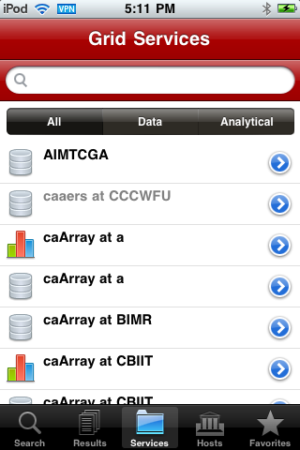 | 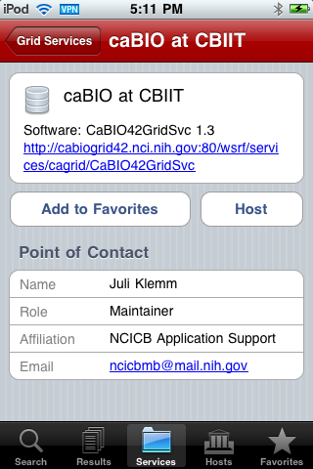

Testing Favorites
Adding a service to Favorites gives that service a star icon. The star icon should appear anywhere the service appears as a row (e.g. Search location selection screen, service list, result list, etc). The Favorites list can be manipulated from the “Favorites” tab.
Testing Steps
- Tap “Add to Favorites” on a service
- Ensure that a yellow star is added to the service icon
- Ensure the star icon appears in other contexts, such as the results screen (first add a searchable service to your Favorites)
- Ensure the service is visible in the Favorites tab
- Do the same for a Host

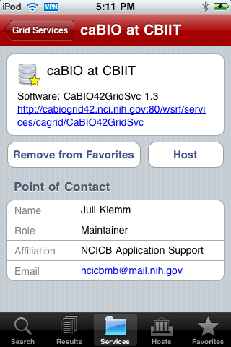 | 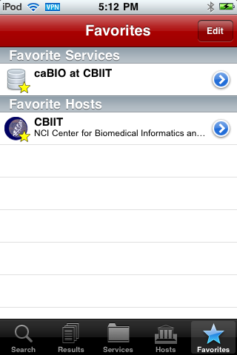

Testing Hosting Center List
Testing Steps
- Tap the “Hosts” tab
- Ensure that you can filter the list by keyword
- Ensure that all academic institutions have a custom icon (Note: hosting institutions which are small companies may not have custom icons but a default “Home” icon)
- Drill into a hosting institution by tapping a blue arrow
- Verify the metadata as follows:
  - Ensure the subtitle reads “Hosting X grid services” where X is the same as the “X Services” button

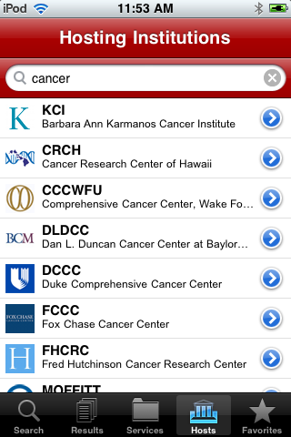 | 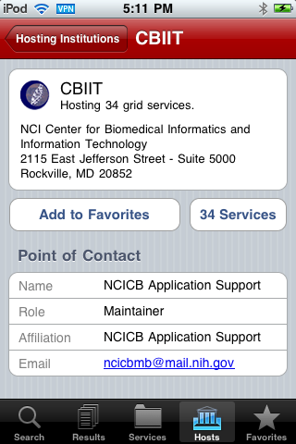

Testing Service Subtitle Options
Testing Steps
- Exit the application and load the “Settings” application
- Tap the caGrid icon
- Tap “Service Subtitle”
- Select each of the subtitle options and test the application to ensure the subtitle displays correctly
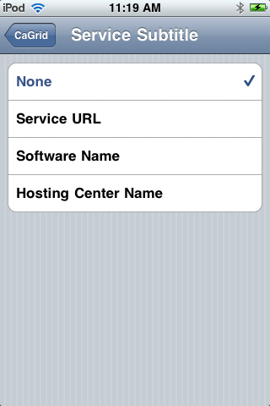
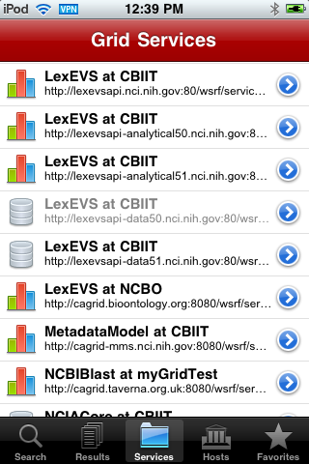 | 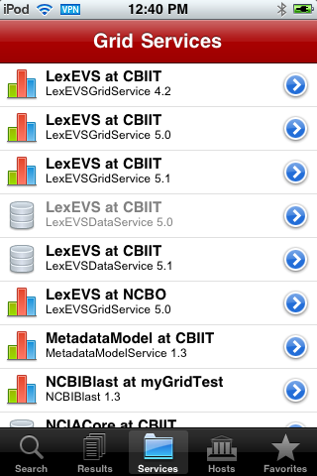 | 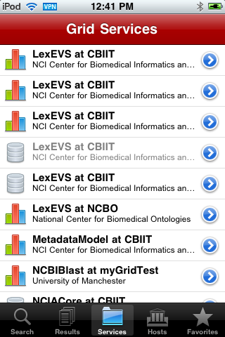
Service URL | Software Name | Hosting Center Name

Testing History Option
Testing Steps
- Exit the application and load the “Settings” application
- Tap the caGrid icon
- Select a higher history option
- Ensure that the application will show additional query results under the Results tab
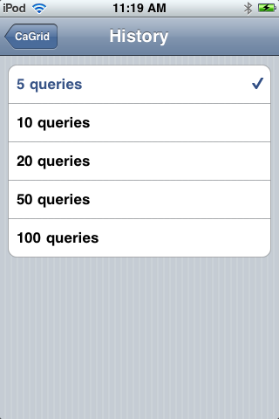

Testing Show Hidden Services Option
Certain services and hosts are hidden by default. These are usually related to grid infrastructure and testing. Hiding a host hides all of its services and if all a hosts’ services are hidden, the host will also be hidden.
Testing Steps
- Exit the application and load the “Options” application
- Tap the caGrid icon
- Turn on the “Show hidden” options
- Ensure that additional services and hosts are shown in orange on the services and hosts lists

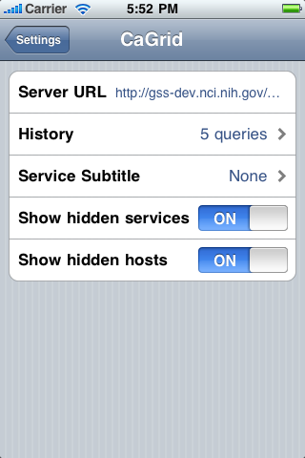
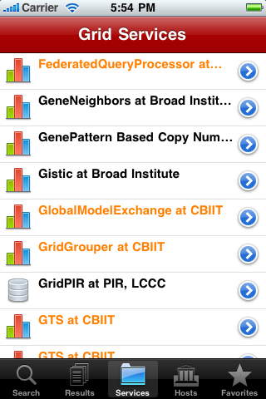 | 